OlyLife × Med Spa  The Aesthetic Edge for Modern Med Spas | PEMF | Terahertz | Vagus Nerve

THE AESTHETIC EDGE FOR MODERN MED SPAS
WHAT IF YOU COULD ACTIVATE RADIANCE AT A CELLULAR LEVEL?
The Vagus Nerve: The Secret to the "Med Spa Glow."
True beauty starts with a regulated nervous system. OlyLife helps shift clients from "stress mode" to "beauty mode," reducing cortisol-induced inflammation and puffiness — amplifying every treatment your spa delivers.

  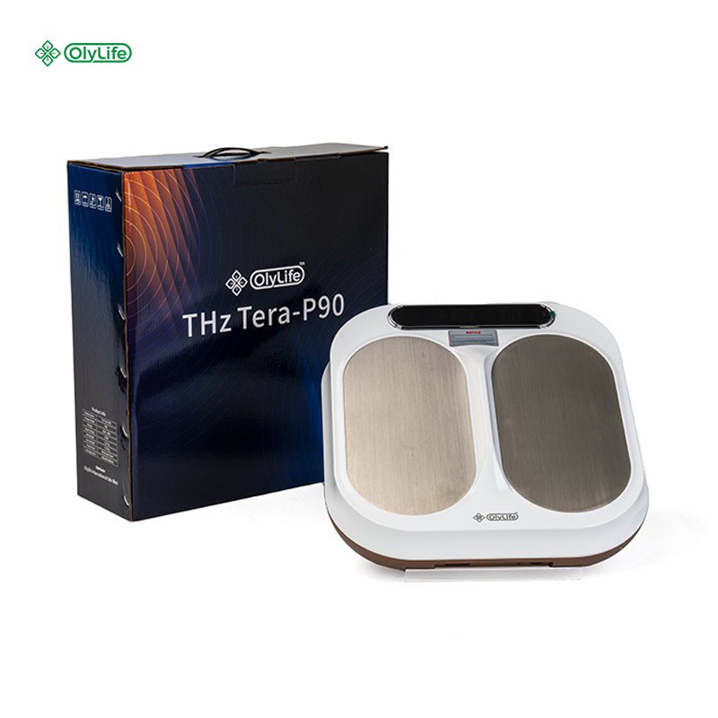
  OlyLife THZ Tera-P90x
  Dual-Core PEMF + Terahertz Frequency
  3–5cm Penetration | Cellular Glow | Vagus Activation
  ✨  DETOXIFY | 💫  ILLUMINATE | 🌸  TRANSFORM
  THE VAGUS NERVE: SECRET TO THE GLOW
  ── ✦ ──
  When the vagus nerve is activated, cortisol drops, inflammation calms, and circulation improves — creating the perfect biological conditions for lasting radiance.
  167+  Patents Registered | 5M+  Global Users
  ELEVATE YOUR SERVICE MENU
  OlyLife THZ Tera-P90x
  Regenerate · Rejuvenate · Reveal
  Sandra Ramnarine
  OLYLIFE WELLNESS CONSULTANT
  📞 781-789-4362
  🌐 vitalwave.polsia.app

These statements are intended for general wellness, comfort, and lifestyle support purposes only. They are not intended to diagnose, treat, cure, or prevent any disease.

OlyLife × The Aesthetic Advantage | Beauty Suite Protocol

THE CELLULAR BEAUTY GAP
YOUR CLIENTS INVEST IN TOPICAL BEAUTY...
but is CELLULAR SLUGGISHNESS diminishing their results?

  WHAT'S BLOCKING TRUE SKIN TRANSFORMATION
  • Slow lymphatic drainage & puffiness — stagnant lymph keeps toxins and fluid trapped in facial tissues, undermining your treatments
  • Poor micro-circulation & uneven skin tone — restricted blood flow limits oxygen and nutrient delivery to skin cells, dulling the complexion
  • Systemic inflammation & accelerated aging — chronic cortisol elevation triggers collagen breakdown and increases skin sensitivity
  • High stress impeding skin repair — sympathetic nervous system dominance suppresses the cellular regeneration cycle that happens during true rest
  PREMIUM MODALITIES FOR THE LUXURY SPA
  How Frequency Technology Complements Your Services
  1 | OlyLife THZ Tera-P90x  Dual-Core PEMF + Terahertz Frequency
  MICRO-CIRCULATION BOOST  3–5cm penetration delivers oxygenated glow from within — no topical needed | SYSTEMIC DETOX  Pre-service prep for facials & body wraps — primes cells for maximum absorption | DEEP RELAXATION  Vagus Nerve activation shifts clients into beauty mode before any treatment begins
  2 | OlyLife Shaken Belt  High-Frequency Mechanical Vibration | 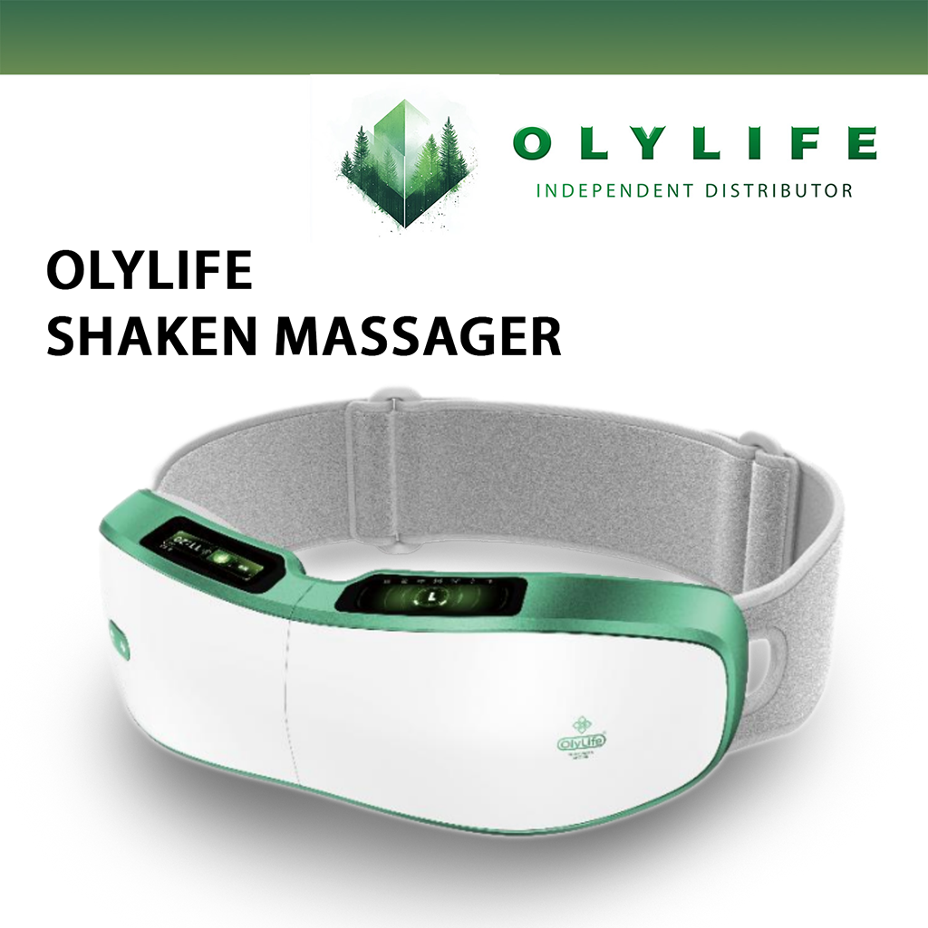
  LYMPHATIC ACTIVATION  High-frequency vibration drives lymph movement, reducing bloating and puffiness | BODY CONTOURING SYNERGY  Post cool sculpting & laser lipo — accelerates drainage for smoother, faster results
  ✦ THE BEAUTY SUITE ROI ANALYSIS
  Feature | Operational Value | Direct Revenue Stream
  Hands-Free Luxury | Staff set P90x in seconds, then focus on high-value prep work | Sell "Cellular Glow" sessions as 30-min standalone add-on
  Treatment Multiplier | Shaken Belt post-body contouring enhances drainage and results | Charge "Bio-Hack" add-on fee ($30–$50) for facials & massage
  Client Experience | Differentiates spa with Terahertz Technology — a true luxury differentiator | Package 10 sessions as "Monthly Glow Membership" for recurring revenue
  MONTHLY GLOW MEMBERSHIP
  Bundle 10 frequency sessions into a recurring membership.
  Predictable Revenue. Clients stay committed. Your spa stays booked.
  Ready to Elevate Your Spa?
  Contact your OlyLife Wellness Consultant
  📞 781-789-4362 🌐 vitalwave.polsia.app
  Sandra Ramnarine

These statements are intended for general wellness, comfort, and lifestyle support purposes only. They are not intended to diagnose, treat, cure, or prevent any disease. Individual results may vary. OlyLife products are wellness devices, not medical equipment.

